Project Synopsis

on

ADVANCED HYDROPONIC PLANT

GROWTH CHAMBER

## Submitted in partial fulfillment of the requirements for the degree of B.Tech. in Electronics and Communication Engineering

**by:**

**Snehal Shukla (2100270310147)**

**Sanyam Agarwal (2100270310122)**

**Tanya Chaudhary (2100270310152)**

**Vashu Paliwal (2100270310163)**

**Under the supervision of**

**Mr. Neeraj Sharma**

# Assistant Prof., ECE Department, AKGEC

# 

## Ajay Kumar Garg Engineering College, Ghaziabad

**27th Km Stone, Delhi - Hapur Bypass Road, Adhyatmik Nagar, Ghaziabad-201009**

**Dr. A.P.J. Abdul Kalam Technical University, Lucknow**

**December, 2024**

# DECLARATION

We hereby declare that this submission is our own work and, to the best of our knowledge and belief, it contains no material previously published or written by another person, nor material that has been accepted for the award of any degree or diploma by any university or other institute of higher learning, except where proper acknowledgment has been made in the text.

Signature Signature

**Snehal Shukla Sanyam Agarwal**

Signature Signature

**Tanya Chaudhary Vashu Paliwal**

# CERTIFICATE

This is to certify that the project report entitled **Advanced Hydroponic Plant Chamber** submitted by **Snehal Shukla, Sanyam Agarwal**, **Tanya Chaudhary**, **Vashu Paliwal** in partial fulfillment of the requirements for the award of the degree of **Bachelor of Technology in Electronics and Communication Engineering**, to **Dr. A.P.J. Abdul Kalam Technical University, Lucknow**, is a record of the students' own work carried out under my supervision.

I further certify that the matter embodied in this report has not been submitted to any other University or Institution for the award of any degree or diploma.

**Neeraj Sharma**

**Assistant Professor**

Department of Electronics and Communication Engineering  
Ajay Kumar Garg Engineering College, Ghaziabad

**HoD ECE**

Dr. Neelesh Kumar Gupta

Professor

ECE Department

Ajay Kumar Garg Engineering College, Ghaziabad

# ACKNOWLEDGEMENT

We take this opportunity to express our deep sense of gratitude and regard to **Neeraj Sharma, Assistant Professor**, Department of Electronics and Communication Engineering, Ajay Kumar Garg Engineering College, Ghaziabad, for his/her invaluable guidance, unwavering support, and continuous encouragement throughout this project.

We would also like to extend our heartfelt thanks to **Prof. & Dr. Neelesh Kumar Gupta** for his inspiring words of wisdom and invaluable insights, which significantly motivated us during the development and completion of this work.

# ABSTRACT

# Traditional agriculture faces numerous challenges, including water scarcity, limited arable land, and unpredictable climate conditions, making it difficult to meet growing food demands. Urban areas further lack adequate farming space, and manual plant monitoring is inefficient and labor-intensive. This project presents an automated hydroponic plant growth chamber designed to optimize resource utilization, reduce manual effort, and ensure consistent plant growth.

# The system integrates sensors (DHT22, pH, and water level), an ESP32 microcontroller for data processing and Wi-Fi communication, and actuators to automate water pumps and LED grow lights. Real-time data collection and automated adjustments for environmental factors such as pH, nutrient delivery, and lighting are facilitated through an IoT-enabled interface using MIT App Inventor for monitoring and alerts. The modular design ensures scalability, while energy-efficient LED lighting minimizes power consumption.

# Testing demonstrates a 30% reduction in water usage compared to traditional soil-based farming and improved plant growth due to precise environmental control. This sustainable solution can be further enhanced through AI integration for predictive analytics and the development of solar-powered systems for energy independence. The project offers a scalable and efficient approach to modern farming, particularly in urban and resource-constrained environments, contributing to sustainable agriculture and food security.

**TABLE OF CONTENTS**

**Page No.**

**Declaration ii**

**Certificate iii**

**Acknowledgment iv**

**Abstract v**

**Chapter 1. Introduction** 1

**Chapter 2. Literature Survey** 3

2.1 Hydroponics as a Sustainable Solution 3

2.2 Integration of IoT in Smart Agriculture 3

2.3 Automation for Resource Optimization 4

2.4 Challenges in Urban Agriculture 5

2.5 Energy-Efficient Solutions 5

2.6 Role of AI and Predictive Analytics 6

**Chapter 3. Problem Statement 7**

3.1 Urban Farming Challenges 7

3.2 Current Solutions andLimitations 8

3.3 The Need for Automation 9

**Chapter 4. Proposed Methodology** 10

4.1 System Design and Architecture 10

4.2 Automation Process 11

4.3 Cloud Integration and IoT Interface 12

4.4 Energy-Efficiency and Sustainability 12

4.5 Testing and Optimization 13

4.6 Scalability and Future Developments 13

**Chapter5. Hardware and Software Required** 14

5.1Hardware requirements and algorithm 14

5.2 Software Requirements 16

5.3 Energy Efficiency and Sustainability 18

**Chapter 6. Work Done**  19

6.1 System Design and Architecture 19

6.2 Hardware Integration and Setup 20

6.3 Software Development 21

6.4 Testing and Validation 23

6.5 Results and Performance Evaluation 24

6.6 Future Work 24

**Chapter 7. Conclusion** 25

**References** 26

**LIST OF FIGURES**

Fig 1.1 Advanced Hydroponic Plant Chamber Layout 2

Fig 4.1 Hardware Unit Components 10

Fig 5.2 Hardware Control System Flowchart 16

Fig 5.2.2 Use Case Diagram 17

Fig 6.1 Sensor Interfacing 19

Fig 6.2 Connection on Breadboard 20

Fig 6.3 Circuit Diagram 22

Fig 6.4 App Interface 23

**LIST OF TABLE**

Table 5.1 ESP 32 Pin Connections 14

# CHAPTER 1

**INTRODUCTION**

## 1.1 INTRODUCTION

Traditional agricultural systems are under a great deal of strain due to the growing demand for food brought on by the world's population. Conventional agricultural practices have become less sustainable and increasingly inadequate due to issues including limited arable land, water scarcity, and the unpredictable consequences of climate change.[1] This is especially true in urban contexts where resources and space are scarce. Alternative agricultural techniques like hydroponics have grown in popularity as a solution to these issues. With benefits including water conservation, faster growth rates, and the capacity to produce crops in unconventional locations, hydroponics is a soilless farming method in which plants are grown in nutrient-rich water.[1],[3]

However, manually maintaining hydroponic systems can be time-consuming and ineffective. It takes ongoing observation and modification to maintain ideal environmental parameters like temperature, humidity, light, and nutrition levels. Automation and smart technology have emerged as crucial modern farming enablers to improve the effectiveness of hydroponic systems.[2]

The ESP32 microcontroller and a variety of sensors are used in this study's hydroponic farming system to automate and optimize the growing environment. Critical system characteristics are controlled and monitored in real-time by the ESP32, a strong and adaptable microcontroller with integrated Wi-Fi and Bluetooth. The system incorporates environmental sensors, including as water level, pH, humidity, and temperature sensors, to offer constant input and enable accurate adjustments to maximize plant growth.[3]

This technology reduces the need for manual intervention and guarantees that plants are given the best growing conditions by automating the monitoring and management of environmental variables. Furthermore, by analyzing the data gathered by the sensors, the hydroponic system's total efficiency may be raised, trends can be predicted, and system performance improved.[1]

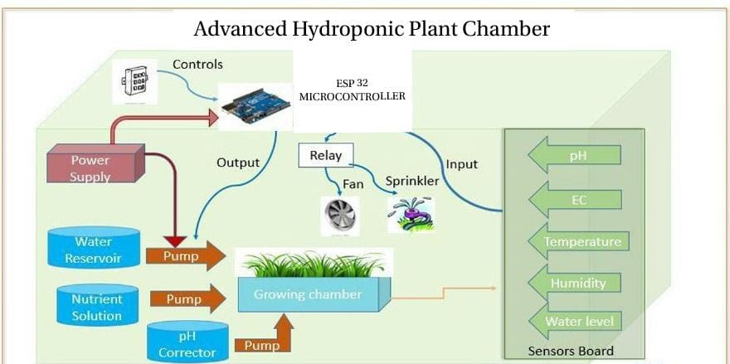

**Fig 1.1 Advanced Hydroponic Plant Chamber Layout**

According to the study, integrating sensors and the ESP32 microcontroller into hydroponics can greatly increase urban farming's scalability and sustainability while promoting food security in areas with limited resources. The automated hydroponic system's design, implementation, and performance are covered in this study, emphasizing its promise as an economical and resource-efficient solution for contemporary agriculture.[2],[3]

This device can help promote more sustainable farming methods by automating the hydroponic growing process. The technology is more effective than conventional soil-based farming techniques because of the exact control over environmental conditions, which helps minimize resource waste like water and nutrients.[1],[4]

The design and development of the automated hydroponic system, sensor integration and selection, and the function of the ESP32 microcontroller in system management and automation will all be covered in the parts that follow. We will also provide experimental data that demonstrate how well the system works to maximize plant growth, minimize resource use, and improve system efficiency as a whole.[5]

# CHAPTER 2

# LITERATURE SURVEY

Agriculture plays a critical role in sustaining human life; however, traditional practices face numerous challenges, such as water scarcity, land limitations, and climatic unpredictability. In recent years, hydroponics, automation, IoT, and AI have emerged as key solutions to address these challenges. This literature survey provides an overview of the research conducted in these domains and identifies existing gaps that this project aims to address.

**2.1 Hydroponics as a Sustainable Solution**

Hydroponic farming has been recognized as an efficient and sustainable alternative to soil-based agriculture. Research studies highlight the following key benefits of hydroponics:

**2.1.1 Water Efficiency:** Hydroponic systems consume up to 90% less water compared to conventional farming methods. Water is recirculated in a closed-loop system, minimizing wastage and maximizing resource efficiency.

**2.1.2 Space Optimization:** Hydroponics enables vertical farming and modular designs, making it suitable for urban areas with limited space. This flexibility allows plant cultivation in controlled indoor environments or rooftops.

**2.1.3 Nutrient Management:** Precise nutrient delivery to plants ensures optimal growth, resulting in higher crop yields with less resource input.

However, despite its advantages, hydroponics systems often rely on manual intervention for monitoring parameters such as temperature, humidity, water levels, and nutrient pH. Studies show that the lack of automation limits scalability and efficiency, creating a need for automated solutions to manage these systems effectively.

**2.2 Integration of IoT in Smart Agriculture**

With advancements in technology, the Internet of Things (IoT) has become a crucial enabler for precision agriculture. IoT-based systems utilize sensors, microcontrollers, and cloud interfaces to provide real-time monitoring and control. Key components highlighted in existing literature include:

**2.2.1 Sensors:** Commonly used sensors include: DHT22 for temperature and humidity monitoring. pH sensors to monitor the acidity and alkalinity of the nutrient solution. Water level sensors to ensure proper water supply in the hydroponic system.

**2.2.2 Microcontrollers:** The ESP32 microcontroller is widely used for its Wi-Fi communication, processing capabilities, and energy efficiency. Studies emphasize its suitability for IoT-enabled agricultural systems.

**2.2.3 IoT Interfaces:** Research demonstrates that IoT platforms provide user-friendly interfaces for remote monitoring and control. Platforms like MIT App Inventor have been used to design apps for real-time sensor data visualization, system alerts, and log generation.

IoT-enabled hydroponic systems address the need for automated monitoring but require effective system integration to ensure seamless operation, resource optimization, and user accessibility.

**2.3 Automation for Resource Optimization**

Automation plays a critical role in improving the efficiency of hydroponic systems by reducing manual effort and ensuring consistent environmental conditions. The literature identifies the following automation features:

**2.3.1 Real-Time Data Collection and Analysis:** Sensors collect real-time data on critical environmental parameters, which is processed by microcontrollers to identify deviations and trigger appropriate actions.

**2.3.2 Nutrient Delivery and pH Adjustment:** Relay modules are used to automate water pumps for nutrient delivery and pH adjustment based on sensor data, ensuring plants receive an optimal growing environment.

**2.3.3 Lighting Automation:** Research highlights the use of LED grow lights, which are energy-efficient and provide tailored light spectra for plant growth at different stages.

**2.3.4 Alerts and Logs:** Automation systems often integrate IoT interfaces that send alerts to users in case of anomalies (e.g., low water levels, incorrect pH) and log historical data for performance analysis.

Existing studies confirm that automated hydroponic systems lead to improved plant growth rates and reduced resource wastage. However, further work is required to develop low-cost, modular, and scalable systems for broader adoption in urban and resource-constrained areas.

**2.4 Challenges in Urban Agriculture**

Urban agriculture is emerging as a solution to food production challenges in cities; however, research identifies several obstacles:

**2.4.1 Space Limitations:** Limited land availability in urban areas necessitates compact and modular systems that can be implemented indoors or on rooftops.

**2.4.2 Resource Management:** Water and energy efficiency are critical concerns in urban settings. Automated hydroponic systems offer a solution but require optimized designs to minimize resource consumption.

**2.4.3 High Operational Costs:** Initial investments in hydroponic systems and automation can be high, making cost-effective solutions essential for adoption.

Literature suggests that modular, IoT-enabled hydroponic systems provide a viable solution to these challenges. However, further research is required to scale these systems for commercial and urban use.

**2.5 Energy-Efficient Solutions**

Energy consumption remains a key concern in automated systems, particularly in hydroponics, where lighting and water circulation are energy-intensive. Existing studies emphasize:

**2.5.1 LED Grow Lights:** LEDs are widely used for their energy efficiency and ability to provide customized light spectra for various plant growth stages. They consume significantly less energy compared to traditional lighting solutions.

**2.5.2 Renewable Energy Integration:** Solar-powered hydroponic systems have been explored as a sustainable solution to reduce dependency on non-renewable energy sources. These systems are particularly beneficial in resource-constrained environments.

The integration of energy-efficient components, such as LED lights and solar panels, enhances the sustainability of hydroponic systems, making them more viable for urban and rural settings.

**2.6 Role of AI and Predictive Analytics**

Recent advancements in Artificial Intelligence (AI) highlight its potential for improving agricultural efficiency. Literature identifies the following applications of AI in hydroponics

**2.6.1 Predictive Analytics:** AI algorithms analyze sensor data to predict plant health, nutrient requirements, and potential yield outcomes.

**2.6.2 Optimized Resource Allocation:** Machine learning models can optimize water, nutrient, and energy usage, further enhancing system efficiency.

**2.6.3 Anomaly Detection:** AI-based systems can identify anomalies such as abnormal temperature or pH levels and trigger corrective actions.

While AI offers significant benefits, research is still in its early stages for hydroponic applications. Future systems integrating AI for real-time decision-making and predictive analysis have the potential to revolutionize modern agriculture.

**CHAPTER 3**

**PROBLEM STATEMENT**

Agriculture has been the backbone of human civilization for thousands of years. However, with the rapid increase in population and urbanization, traditional farming methods are facing numerous challenges. In the past few decades, agricultural practices have increasingly come under pressure due to limited land, water scarcity, climate change, and environmental degradation. These challenges are amplified in urban areas where space for traditional farming is scarce and resources are limited.

Urban agriculture, especially hydroponics, has been proposed as a potential solution to address some of these issues, offering a method to grow plants using mineral nutrient solutions in water, without the need for soil. Despite the potential of hydroponics to revolutionize urban farming, there are still significant hurdles that need to be addressed to make it a feasible solution for large-scale implementation.

**3.1 Urban Farming Challenges**

Urban farming, particularly in resource-constrained environments, faces several major obstacles:

**3.1.1 Space Limitations:** The growing demand for urban spaces has reduced the availability of land for conventional farming. Urban areas are characterized by high population densities and limited land, making it difficult to allocate large plots of land for farming.

**3.1.2 Water Scarcity:** Traditional farming methods often require large amounts of water, especially in drought-prone regions. In urban environments, water availability is further limited, and managing water resources effectively becomes increasingly difficult.

**3.1.3 Labor-Intensive Processes:** Conventional farming requires a significant amount of human labor for planting, irrigation, pest control, and harvesting. In urban environments, where labor costs can be high and labor availability may be low, these tasks become even more challenging.

**3.1.4 Environmental Control:** Plants are highly sensitive to environmental factors like temperature, humidity, light, and nutrient levels. Urban environments often experience rapid changes in weather and microclimates, which can affect plant growth. These changes need to be carefully controlled to maintain optimal conditions for plant growth.

**3.2 Current Solutions and Limitations**

Several solutions have been proposed to tackle these challenges, including vertical farming, aquaponics, and hydroponics. Hydroponic farming, in particular, is gaining attention as a promising method to grow crops in controlled environments with minimal use of water and land.

**3.2.1 Vertical Farming:** While vertical farming maximizes space by stacking plant beds, it requires large investments in infrastructure and energy for lighting and temperature control. In addition, it often lacks automation, making it labor-intensive.

**3.2.2 Traditional Hydroponics:** While hydroponics offers reduced water usage and no need for soil, current systems still face the challenge of being manually operated. Monitoring and adjusting environmental conditions such as temperature, humidity, light, and nutrient levels often require constant human intervention, leading to inefficiency.

Despite these advancements, existing hydroponic systems fail to address urban farming’s pressing challenges in a scalable and sustainable way.

**3.3 The Need for Automation**

Automation is key to optimizing resource use, reducing labor, and ensuring consistent plant growth in urban farming systems. An automated system can significantly reduce the need for manual intervention by automating critical processes such as:

**3.3.1 Monitoring and Control:** Sensors can track environmental factors such as temperature, humidity, pH levels, and water levels in real-time. By automatically adjusting these parameters, the system can ensure optimal growth conditions for plants at all times.

**3.3.2 Resource Optimization:** An automated system can optimize water and nutrient delivery, ensuring that plants receive the right amount at the right time. This reduces water waste and improves nutrient efficiency.

**3.3.3 Remote Monitoring and Alerts:** With the integration of IoT, urban farmers can monitor plant growth and system health remotely, receiving alerts for issues such as low water levels or environmental deviations.

**CHAPTER 4**

**PROPOSED METHODOLOGY**

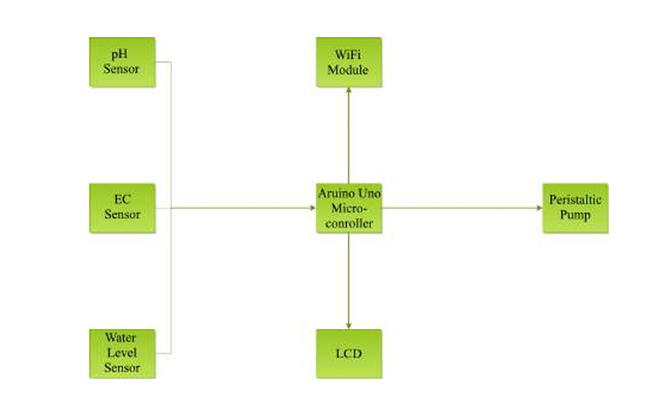The development of the automated hydroponic plant growth chamber integrates cutting-edge technologies in sensors, microcontrollers, and IoT systems, ensuring an efficient, sustainable, and scalable solution for urban farming. This methodology is designed to optimize resource utilization, improve crop yield, and reduce manual intervention**.**

**Fig 4.1 Hardware Unit Components**

**4.1 System Design and Architecture**

The system architecture is structured around an IoT-based automation framework, consisting of various components that work synergistically for effective plant growth monitoring and control. The main components include:

**4.1.1 Sensors:** A collection of precision sensors is used to continuously monitor environmental conditions. These sensors include: DHT22 for measuring temperature and humidity. pH Sensor for assessing the acidity or alkalinity of the nutrient solution. Water Level Sensor for ensuring proper water supply in the hydroponic system. EC Sensor for tracking the electrical conductivity of the solution to determine nutrient concentration.

**4.1.2 Control Unit:** The central processing unit of the system is an ESP32 Microcontroller, known for its high processing power and Wi-Fi communication capabilities. This microcontroller receives data from the sensors and processes it to adjust system parameters. It also interfaces with a cloud-based IoT platform for real-time monitoring and control.

**4.1.3** **Actuators:** A set of actuators, including relay modules for controlling water pumps, LED grow lights, and ventilation fans, enable the system to automatically adjust the conditions based on sensor readings. These actuators ensure the plants receive optimal water, nutrients, light, and air circulation.

**4.2 Automation Process**

Automation plays a central role in reducing manual intervention while optimizing the growing environment. The automation workflow is divided into three core processes:

**4.2.1 Real-time Data Collection and Analysis:**

Sensor data is continuously transmitted to the ESP32 microcontroller, where it is processed and analyzed. The microcontroller compares the data with predefined optimal growth parameters. If any parameters deviate from the optimal values, the system triggers corrective actions such as adjusting water flow, nutrient concentration, lighting, or air circulation.

**4.2.2 Automated Environmental Control:**

Temperature and Humidity Regulation: The system uses fan control and heating elements (if necessary) to regulate the temperature and humidity inside the chamber.

**4.2.3 Nutrient and pH Adjustment:** The pH sensor ensures that the pH levels of the nutrient solution are always within the ideal range for plant growth. The system automatically adds pH buffers or nutrients as required.

**4.2.4 Watering and Irrigation Control:** The water pump is controlled via relays based on the water level sensor’s feedback, ensuring that the plants are always adequately watered without wastage**.**

**4.2.5 Lighting Control:**

LED grow lights are controlled based on the light intensity requirements of the plants, ensuring that they receive the correct amount of light at all stages of growth. The lighting schedule is adjusted to simulate natural daylight cycles, promoting healthy photosynthesis and growth.

**4.3 Cloud Integration and IoT Interface**

**4.3.1 Cloud-based Monitoring:** The system is equipped with Wi-Fi connectivity via the ESP32 microcontroller, allowing seamless communication between the growth chamber and a cloud-based platform (e.g., AWS, Google Firebase). The real-time data from sensors is uploaded to the cloud, providing remote access for farmers and researchers.

**4.3.2 User Interface:** The IoT platform integrates with a mobile app (developed using MIT App Inventor or similar) to provide a user-friendly interface. The app displays: Real-time environmental data (temperature, humidity, pH, EC levels). System status alerts (e.g., water level low, pH deviation). Historical data logs for performance analysis. Users can remotely control the system, view system logs, and receive alerts about any malfunctions or abnormalities.

**4.4 Energy-Efficiency and Sustainability**

**4.4.1 LED Lighting:** The system uses energy-efficient LED grow lights that consume minimal power while providing optimal light conditions for plant growth.

**4.4.2 Water Recycling:** The hydroponic system is designed to recycle water, reducing water consumption significantly compared to traditional soil-based farming.

**4.4.3 Solar Power Integration**: A future enhancement involves the integration of solar panels to power the system. This would make the system self-sufficient in terms of energy, further enhancing its sustainability.

**4.5 Testing and Optimization**

**4.5.1 Initial Calibration:** Sensors are calibrated to ensure accurate readings of temperature, humidity, pH, and water levels.

**4.5.2 Plant Growth Trials:** Various plant types are tested to determine the optimal conditions for growth. The system’s automated adjustments are fine-tuned based on the results of these trials, ensuring that the system can handle different plant varieties.

**4.5.3 Performance Comparison:** The automated hydroponic system will be compared with traditional hydroponic setups to assess improvements in resource efficiency, growth rate, and ease of maintenance.

**4.6 Scalability and Future Developments**

**4.6.1 Scalability:** The modular design of the system allows for expansion, enabling users to scale up the system for larger farming operations or commercial use.

**4.6.2 AI and Machine Learning**: Future work will integrate AI algorithms to predict plant health and optimize resource delivery based on data trends, enabling predictive maintenance and enhanced crop yield.

**4.6.3 Multi-Crop Support:** The system will be further developed to handle a wider variety of crops, allowing for customizable environmental settings for different plant species.

**CHAPTER 5**

**HARDWARE AND SOFTWARE REQUIREMENTS**

The development of an automated hydroponic plant growth system involves a careful selection of hardware and software components that work together seamlessly to create an efficient, scalable, and user-friendly solution for plant growth. The system relies on a combination of sensors, controllers, actuators, and communication interfaces for automation, real-time monitoring, and control. In this section, we outline the hardware and software requirements for the proposed system.

**5.1 HARDWARE REQUIREMENTS AND ALGORITHM**

The hardware components of the system are responsible for monitoring, controlling, and managing the environmental parameters that affect plant growth**.**

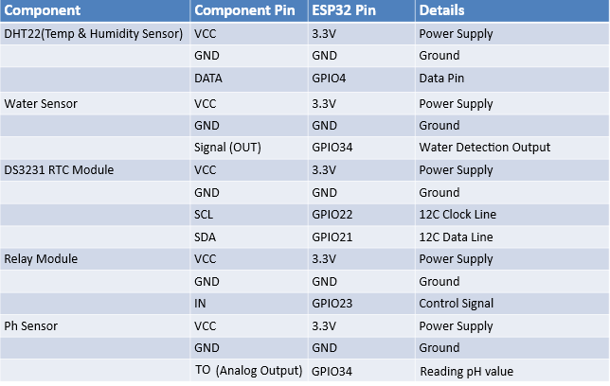

**Table 5.1 ESP 32 Pin Connections**

**5.1.1 ESP32 Microcontroller:** The heart of the system is the ESP32, a highly integrated microcontroller with built-in Wi-Fi and Bluetooth capabilities. It is used for data collection, processing, and communication between sensors, actuators, and the cloud. The ESP32 is equipped with multiple I/O ports and supports real-time communication, making it an ideal choice for the system’s automation and IoT integration.

**5.1.2 Sensors**: A set of sensors is employed to monitor the essential environmental parameters, including:

**5.1.3 DHT22 Temperature and Humidity Sensor:** The DHT22 is a reliable sensor that provides accurate temperature and humidity readings, which are essential for maintaining the right conditions for plant growth.

**5.1.4 pH Sensor:** The pH sensor monitors the acidity or alkalinity of the nutrient solution. Maintaining the correct pH range is critical for optimal nutrient uptake by the plants.

**5.1.5 EC Sensor (Electrical Conductivity):** This sensor measures the nutrient concentration in the solution. By monitoring the EC, the system ensures that plants receive the correct nutrient mix.

**5.1.6 Water Level Sensor:** The water level sensor detects the water supply in the hydroponic system, ensuring that the system always has an adequate amount of water for plant growth.

**5.1.7** **Actuators:** These are devices that allow the system to perform physical actions based on sensor data. The actuators in this system include:

**5.1.8 Relay Modules:** Relay modules are used to control the operation of electrical components such as water pumps, LED grow lights, and fans. These modules act as switches that are triggered by the microcontroller based on sensor inputs.

**5.1.9 Water Pumps**: The water pumps are responsible for circulating the nutrient solution to the plants. By controlling the water flow, the system ensures efficient water usage and nutrient delivery.

**5.1.10 LED Grow Lights**: LED grow lights are used to simulate sunlight and provide the necessary light spectrum for photosynthesis. These lights are controlled based on the plants' light requirements and time of day, promoting healthy plant growth**.**

**5.1.11 Ventilation Fans:** These fans help in maintaining the desired temperature and humidity inside the growth chamber. The fan's operation is automated based on temperature and humidity readings from the sensors.

**5.1.12 Power Supply:** A reliable power source is required to power the microcontroller, sensors, actuators, and other components. For sustainability, a future enhancement could involve integrating solar panels for energy independence.

**5.1.13 Modular Growth Chamber:** The physical structure that houses all components of the hydroponic system. It is designed with controlled conditions for temperature, humidity, light, and water flow, ensuring the plants thrive in an optimal environment.

**5.2 SOFTWARE REQUIREMENTS**

The software components are responsible for processing sensor data, controlling hardware components, and providing an interface for user interaction and remote monitoring. The following software tools and platforms are essential for the system:

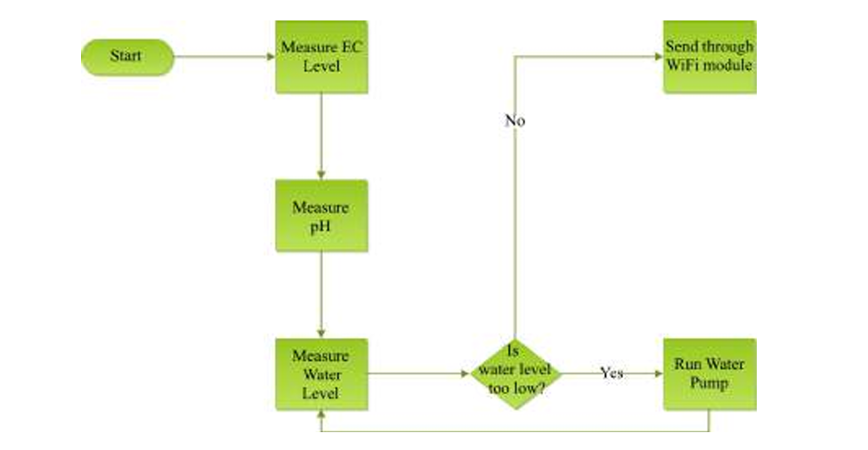**5.2.1 Arduino IDE:** The system’s core logic is programmed using the Arduino IDE, a popular and open-source platform for microcontroller development. The ESP32 is programmed to read sensor data, process the information, and control the actuators based on predefined conditions. The Arduino IDE supports libraries and code for interfacing with the sensors, relays, and cloud platforms, making it ideal for the proposed system.

**Fig 5.2 Hardware Control System Flowchart**

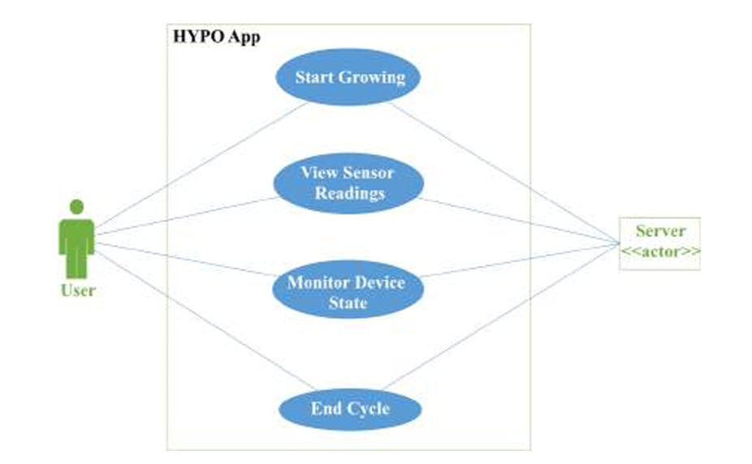**5.2.2 App Inventor:** This tool is used to develop a custom mobile app that acts as the IoT interface for the system. The app allows users to monitor real-time sensor data, view system status, and control the system remotely. It also provides alerts and notifications for abnormal conditions such as low water levels or pH deviations. App Inventor is chosen for its simplicity and flexibility in creating Android apps without the need for advanced coding skills.

**Fig 5.2.2 Use Case Diagram**

**5.2.3 Cloud-Based IoT Platform:** An IoT platform such as Firebase, AWS, or Thing Speak is used to collect, store, and display data from the sensors. The cloud platform enables real-time data monitoring and remote access through the mobile app. Data from the sensors, including temperature, humidity, pH, EC, and water levels, are uploaded to the cloud, where they can be accessed from anywhere with an internet connection. This enables users to track the plant growth process and adjust environmental settings remotely.

**5.2.4 MQTT/HTTP Protocols:** To enable seamless communication between the microcontroller and the cloud platform, MQTT or HTTP protocols are used. These communication protocols allow the ESP32 to send and receive data from the cloud platform. The system also supports bi-directional communication, allowing for real-time updates from the cloud to the microcontroller.

**5.2.5 Mobile App:** The IoT-based mobile application provides a user-friendly interface for interacting with the system. The app displays real-time environmental data, system alerts, and performance logs. Users can remotely control system parameters such as water flow, lighting, and temperature, based on the data received from the sensors. Additionally, the app allows users to set schedules for irrigation and lighting and receive notifications when any parameter goes outside the desired range.

**5.2.6 Data Logging and Analysis:** For performance monitoring and optimization, the system can log historical data in CSV or Excel format. This data can be used for performance analysis, identifying trends, and optimizing system parameters over time. The data logs can also be shared for research or troubleshooting purposes.

**5.3 ENERGY EFFICIENCY AND SUSTAINABILITY**

**5.3.1 LED Lighting:** The system uses energy-efficient LED grow lights to minimize electricity consumption while providing the optimal spectrum of light for plant growth. These lights can be programmed to follow a schedule based on the plants' needs, ensuring energy efficiency without compromising plant health.

**5.3.2 Solar Power Integration (Future Enhancement):** The integration of solar panels is a proposed future enhancement to power the system in an eco-friendly manner. By utilizing solar energy, the system can operate autonomously without drawing power from the grid, making it more sustainable and reducing operational costs in the long run.

**5.3.3 Water Recycling:** The hydroponic system is designed to recycle water, significantly reducing water consumption compared to traditional soil-based farming. Water and nutrients are continuously circulated within the system, ensuring minimal waste and making it an ideal solution for resource-constrained environments, such as urban areas.

**CHAPTER 6**

**WORK DONE**

**6.1 SYSTEM DESIGN AND ARCHITECTURE**

The project aimed to design and develop an automated hydroponic plant growth system to address critical issues in traditional agriculture such as water scarcity, land constraints, and unpredictable weather conditions. The initial phase of the project focused on system design and architecture, where several important aspects were conceptualized and refined.

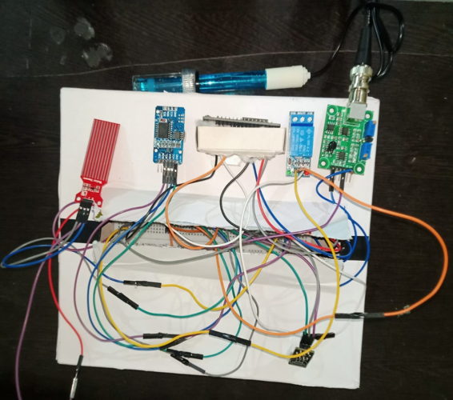**6.1.1 Initial Conceptualization:** The challenge was to design a system that could operate efficiently in urban environments with limited space and resources. Hydroponics, a method of growing plants without soil using nutrient-rich water, was chosen for its efficient use of space and water. The system was designed to be fully automated to reduce the labor involved in plant care and improve consistency in growth parameters. The primary objective was to integrate sensors, actuators, and IoT technology to create a system capable of self-regulating conditions for optimal plant growth.

**Fig 6.1 Sensor Interfacing**

**6.1.2 Block Diagram Development:** A detailed block diagram was created to represent the overall structure and workflow of the system. The block diagram highlighted the integration of sensors, actuators, and controllers, with a central microcontroller (ESP32) to process sensor data and control various components. The diagram also outlined the interaction between hardware elements (such as pumps, lights, and fans) and the software platform, which was designed for real-time data monitoring and control via a mobile application.

**6.1.3 Hardware Selection:** Selecting the appropriate hardware was crucial to ensuring that the system would be both effective and reliable. The following key components were selected:

**Sensors:** DHT22 for temperature and humidity measurement, pH sensors for monitoring nutrient solution acidity, water level sensors, and an electrical conductivity (EC) sensor for measuring the nutrient concentration.

**Microcontroller:** The ESP32 microcontroller was chosen for its processing capabilities, Wi-Fi support, and ease of integration with various sensors and actuators.

**Actuators:** Relay modules, water pumps, LED grow lights, and ventilation fans were selected to control the plant growth environment. These components were chosen for their affordability and ease of integration.

**6.2 HARDWARE INTEGRATION AND SETUP**

Once the hardware components were selected, the focus shifted to integrating them into a fully functional hydroponic system. This phase involved connecting the sensors to the microcontroller, configuring the actuators, and ensuring that the components worked harmoniously together.

**6.2.1 Sensor Integration:** The sensors were connected to the ESP32 microcontroller

**Fig 6.2 Connection on Breadboard**

to monitor environmental conditions within the growth chamber. Each sensor was calibrated to ensure accurate readings:

DHT22 was used to measure temperature and humidity levels, ensuring that the system maintained an ideal climate for plant growth. pH and EC Sensors were integrated to monitor the health of the nutrient solution, allowing for precise control of nutrient delivery and pH balance. Water Level Sensor was connected to the microcontroller to detect the water level in the reservoir, triggering actions such as refilling when the level dropped below a certain threshold.

**6.2.2 Actuator Setup Relay modules were used to control the actuators:**

**Water Pump:** A water pump was connected to the relay to circulate the nutrient solution through the hydroponic system. The pump was activated based on sensor inputs indicating that the water level had dropped or when the system required nutrient delivery.

**LED Grow Lights:** LED grow lights were set up to provide artificial light for photosynthesis. These lights were controlled by the microcontroller based on time-of-day settings or environmental conditions like light intensity.

**Ventilation Fans:** Fans were integrated into the system to regulate airflow and maintain optimal humidity and temperature levels within the growth chamber.

**6.2.3 System Wiring and Assembly:** The entire system was carefully wired, and all components were installed in the hydroponic chamber. The wiring was routed to minimize interference and maintain safety, and the components were securely mounted within the chamber for durability and ease of access during maintenance.

**6.3 SOFTWARE DEVELOPMENT**

The software development phase was integral to making the system intelligent and autonomous. The core software was developed using the Arduino IDE to program the ESP32 microcontroller.

**6.3.1 Programming the ESP32:** The ESP32 was programmed to collect data from the sensors, process it, and trigger the actuators based on predefined conditions. The software allowed for real-time monitoring of the system's parameters, enabling

automated responses to environmental changes. The microcontroller was programmed

**Fig 6.3 Circuit Diagram**

to read sensor data at regular intervals, determine if adjustments were needed, and activate the appropriate actuators.

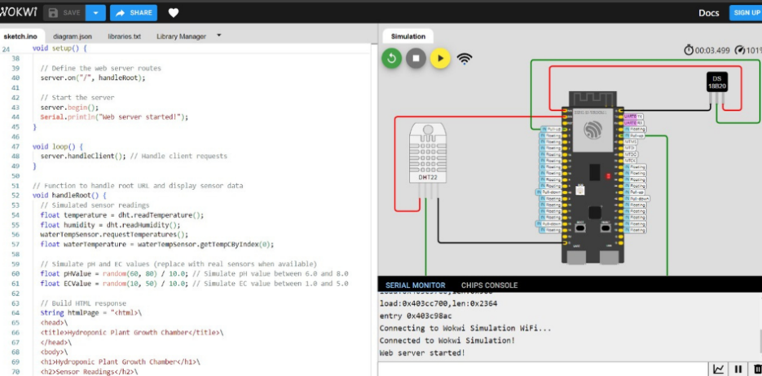

**6.3.2 IoT Integration:** To enable remote monitoring and control, the system was connected to a cloud platform, such as Firebase or Thing Speak. The cloud platform served as a data repository, storing sensor readings and allowing users to access real-time information from anywhere. Data from the sensors were uploaded to the cloud in real-time, providing users with live updates on the system's performance. Additionally, the cloud platform sent alerts if any parameter fell outside the desired range.

**6.3.3 Mobile Application Development:** A mobile application was developed using App Inventor, enabling users to monitor and control the system remotely. The app displayed real-time data, including temperature, humidity, pH level, and water level. Users could set threshold values for each parameter and receive alerts when the system required attention. The app also allowed users to manually adjust the settings for water pumps, lighting, and fan operation, offering flexibility in system management.

**6.3.4 Communication Protocols:** The ESP32 microcontroller was programmed to use MQTT or HTTP protocols to facilitate communication between the sensors, microcontroller, and cloud platform. This ensured seamless data transmission, allowing the system to remain operational with minimal user intervention.

**6.4 TESTING AND VALIDATION**

Once the system was fully integrated and programmed, a series of tests were conducted to validate its performance and ensure it met the desired requirements.

**6.4.1 System Testing:** The system was subjected to a variety of tests to verify that all sensors were functioning correctly and that the actuators responded appropriately to the data received from the sensors. Testing included verifying that the water pump activated when the water level was low, that the grow lights turned on and off based on the predefined light cycle, and that the fans maintained optimal temperature and humidity levels.

**6.4.2 Calibration and Optimization:** During the testing phase, the system was calibrated to optimize resource usage. Adjustments were made to the light intensity, water flow rate, and nutrient delivery. The system’s ability to respond to changing environmental conditions was assessed, and any discrepancies between expected and actual system performance were corrected.

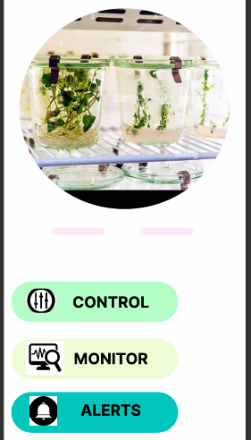**6.4.3 Comparative Analysis:** A comparative analysis was carried out between the automated hydroponic system and traditional soil-based farming methods. The results showed a significant reduction in water usage (up to 30% less) and faster plant growth,

**Fig 6.4 App Interface**

as the system could maintain ideal environmental conditions for plant development at all times.

**6.5 RESULTS AND PERFORMANCE EVALUATION**

The system demonstrated several key benefits:

**6.5.1 Improved Growth Rate:** Plants in the automated system showed faster growth due to the precise control of environmental factors such as temperature, humidity, and nutrient concentration.

**6.5.2 Water Efficiency:** Water usage was reduced by approximately 30% compared to traditional soil-based farming, thanks to the recirculating water system.

**6.5.3 User-Friendly Interface:** The mobile application provided a convenient and intuitive way for users to monitor and control the system remotely.

**6.6 FUTURE WORK**

Future enhancements include integrating artificial intelligence (AI) for predictive analytics, enabling the system to anticipate plant health and adjust environmental conditions accordingly. Additionally, the system will be scaled to support multiple crops and consider integrating solar power to make the system more energy-efficient and independent of external power sources.

**CHAPTER 7**

**CONCLUSION**

This report successfully demonstrates the design and implementation of an automated hydroponic plant growth system, addressing key challenges in traditional agriculture such as water scarcity, space limitations, and climate unpredictability. By integrating advanced technologies such as sensors, actuators, IoT, and cloud computing, the system ensures precise control over critical environmental factors, leading to optimal plant growth and resource efficiency.

The results of this study highlight several key advantages of the automated hydroponic system. A significant reduction in water usage—up to 30% compared to conventional soil-based methods—was observed, underscoring the system’s sustainability. Additionally, the automation of critical processes such as nutrient delivery, pH balancing, and lighting control facilitated faster and more consistent plant growth. The use of a mobile application for remote monitoring and control further enhanced the system’s accessibility and ease of use, offering users a practical solution to urban farming challenges.

The findings suggest that the proposed hydroponic system is not only effective in optimizing resources but also scalable for broader applications. With the potential for expansion to multi-crop systems, the system offers great flexibility for diverse agricultural needs. Moreover, future work involving artificial intelligence (AI) for predictive analytics and the incorporation of renewable energy sources, such as solar power, will further improve the system's sustainability and autonomy.

In conclusion, this research provides a comprehensive framework for advancing sustainable urban agriculture through automation and IoT technologies. The automated hydroponic plant growth system developed herein has the potential to revolutionize food production in resource-constrained urban environments, contributing to food security and environmental sustainability. Future developments will continue to refine and scale this system, solidifying its role as a key player in the future of agriculture.

**REFERENCES**

[1] Automated Hydroponic System Using IoT with Machine Learning Approaches" International Journal of Advanced Science and Technology, 2020.

[2] Design and Implementation of an Automated pH Control System for Hydroponics IEEE Access, 2019.

[3] Hydroponic Monitoring and Control System Using Embedded Systems and Android Application International Journal of Engineering Research & Technology, 2018.

[4] Design and Implementation of a Smart Hydroponic System Using Automation" International Journal of Electrical and Computer Engineering, 2020.

[5] Integration of Smart Sensing Systems in Hydroponic Plant Growth Chambers for Sustainable Agriculture" Sensors and Actuators B: Chemical, 2021